Renju lesson on November 2, 2000

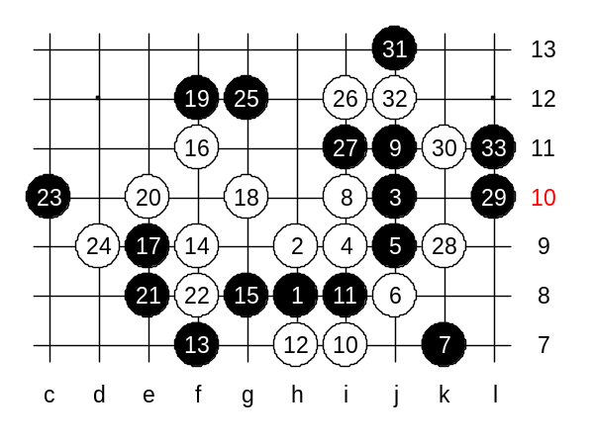
Hello everyone! Good to see you all here! We can begin the lesson. Last week we studied the first game of Meijin match Nakamura vs Hasegawa. That was a lead to the new opening theme. We will continue learning d3 opening. As it is the most balanced opening in my opinion, therefore we seldom can show winning endings for either side. We will try to analyse and discuss those variants and end them when we have clear understanding about the advantage issue. Lets begin. Move 4-i9 is the only possible white move in this opening. Any other 4th move loses. Last week I listed the possible 5th moves. Who still remembers them? Who can list all of them now? Last week we began to learn about 5-j9. Lets continue with it. The 6th move you see now (j8) is also very natural move. Lets follow the variant of the game Nakamura-Hasegawa until move 13. Move 14-f9 is the correct move. In my game with Nakamura, I played 15-e10, but unfortunately that move loses. Who wants to know how white can win there, he can read my article about the match in our website. Actually, there are only two possible 15th moves. Does anyone of you know them? Move 15-e9 loses, you could see that in the medium level homework last week. Move 15-g8 - one of the correct moves. How about another? Yes, 15-g9 is correct, too. Lets begin with 15-g8. Black's idea after this 9th move is always the same - to try to defend white activity while keeping promising source on the right side and future base on the lower side. Black will follow the same plan here too. White has got the temp and black is forced to continue in defense. But if white fails the attack, then black has very good chance to win later on either right or lower side. As an example, I will show the test game I played some days ago. The most popular white move is 16-f11 now. I guess that move comes from Russia, because recent Russian tournaments have lots of games with such 16th move. And white has been very successful there. It is still hard to say which black move is best or even which is correct. Therefore, I cannot tell you some solid answers here. I can only say what I have played and analysed. This game I played with my countrymate Ants Soosyrv. Ants was white and used the Russian player's move f11. In the games in Moscow Open, every time black had used the same 17th move (17-g9). Maybe it is the reason of black loss, hard to say. However, I do not like that move anyway. In my test game with Ants, I used another 17th move. I still don’t know if the 17-e9 I played is good or not. Ants continued with traditional 18-g10 which was also used in games of 17-g9. Now I played a defense move f12 and stayed in waiting position. White has to keep up the initiative. How to do? Move e10 perhaps. By the 25th move black has defended the white attack. I have a question, can white attack now in any way? White cannot play d11 now or something, because of absence of VCF threat (black would win on the right side in that case). Therefore white continues to i12. Black can defend, and also create some of its own material. As white cannot attack, one has to defend - k9. Next black move, k11, black has already got the initiative. This is how I played in the test game, too. Move 33-L11 is very tricky. If white plays k12 after that, black wins. Now I played g5. The further moves are not important. I won the game on the lower side later. Anyone can see the black advantage and space control on the lower side.

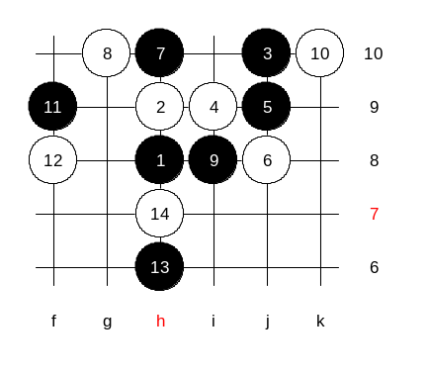
Lets take a look at another 7th move, too. Move 7-g10 was very popular before. Even in database records, this 7th move has been played 3 times more than 7-k7. Traditional 8th move is g10. The following moves you see now are all natural and expected. The game is very balanced and is continued with positional style moves only. After 14-h7 there are no common continuations. People use different 15th moves here. But no matter how black would play, the black attack will fail soon and white gets the advantage. That is the reason why people prefer 7-k7 these days as it gives black more chance to win (or maybe lose, too ^_^)

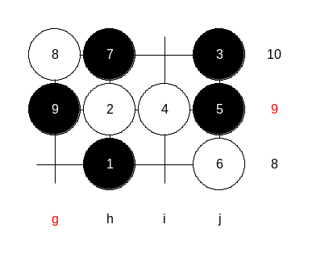
This 9th move has been played many times in renju tournaments, but actually white can win here. This is the medium level homework. You have to find how white can win here.

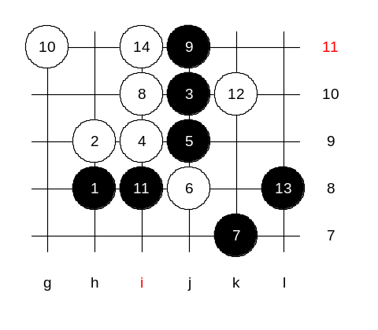
Now, advanced level homework. Please find the black win here.
It is not easy, believe me. It does not need to be VCT or VCF. I want you to practice such position, because that way you learn about considering white's counter attack possibilities. You even do not need to publish all possible variants. If you get the idea right, that is also worth to be considered as correct answer. Today both medium and advanced level players got harder homework than usually. I wish you good luck in solving them. Remember, answering renju homework gives you creditpoints. IF possible, try to answer both homework questions. The class is over now. Thank you all for coming, I wish you nice week. See you next Thursday!

